EGFR (E746-A750)del
Catalog Number: CR-M26235
Gene Symbol: EGFR/HER1/ERBB1
Description: Anti-EGFR (E746-A750)del Mouse Monoclonal Antibody

Background: EGFR is a receptor tyrosine kinase binding ligands of the EGF family and activating several signaling cascades to convert extracellular cues into appropriate cellular responses. It activates at least 4 major downstream signaling cascades including the RAS-RAF-MEK-ERK, PI3 kinase-AKT, PLCgamma-PKC and STATs modules. Defects in EGFR are associated with lung cancer (LNCR).
Immunogen: A synthetic peptide from the internal region of EGFR which includes the deletion of E746-A750, human origin.
Tested applications: ELISA, WB
Recommended dilutions:
ELISA: 1:1000-1:5000
WB: 1:500-1:1000
Concentration: 1 mg/ml
Host: Mouse
Clonality: Monoclonal
Purity: Purified from ascites
Format: Liquid
Storage buffer:
Preservative: no
Constituents: PBS (without Mg²⁺ and Ca²⁺), pH 7.4, 150 mM NaCl, 50% glycerol
Species Reactivity: Recognizes EGFR (E746-A750), but not wild type EGFR of vertebrates.
Storage Conditions: Store at -20°C. Avoid freeze / thaw cycles.

Western blot:
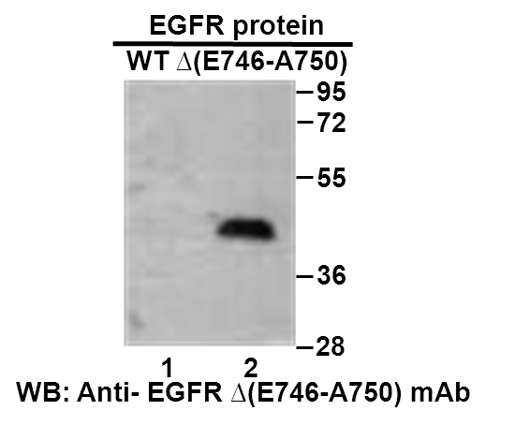
Western blot analysis of recombinant EGFR (E746-A750) and wildtype proteins. Purified His-tagged EGFR (E746-A750)del protein (aa 702-987) and wild-type protein (aa 702-987) were blotted with anti- EGFR (E746-A750)del mouse antibody (Cat. #26235).

科博瑞（武汉）生物科技有限公司
TEL：027-87615885 15972062685
- mail：3636901710@qq.com
Web:www.coburybio.com

